PNC Algorithm

[1. Balook and the mushroom](https://pnc-blocky.netlify.app/exercices/2019/e-1-0/index.html)

[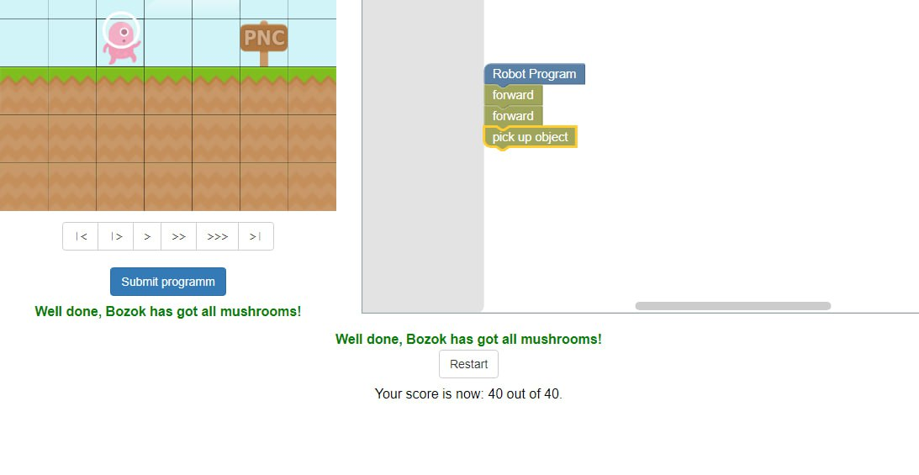](https://pnc-blocky.netlify.app/exercices/2019/e-1-0/index.html)

[2. The diamond](https://pnc-blocky.netlify.app/exercices/2019/e-1-1/index.html)

[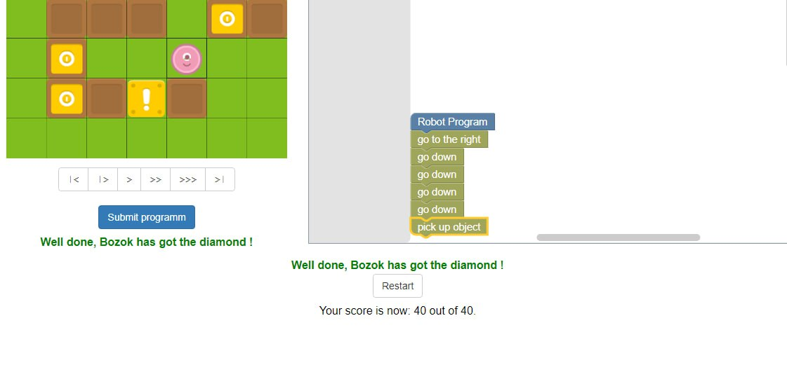](https://pnc-blocky.netlify.app/exercices/2019/e-1-1/index.html)

[3. The other diamond](https://pnc-blocky.netlify.app/exercices/2019/e-1-2/index.html)

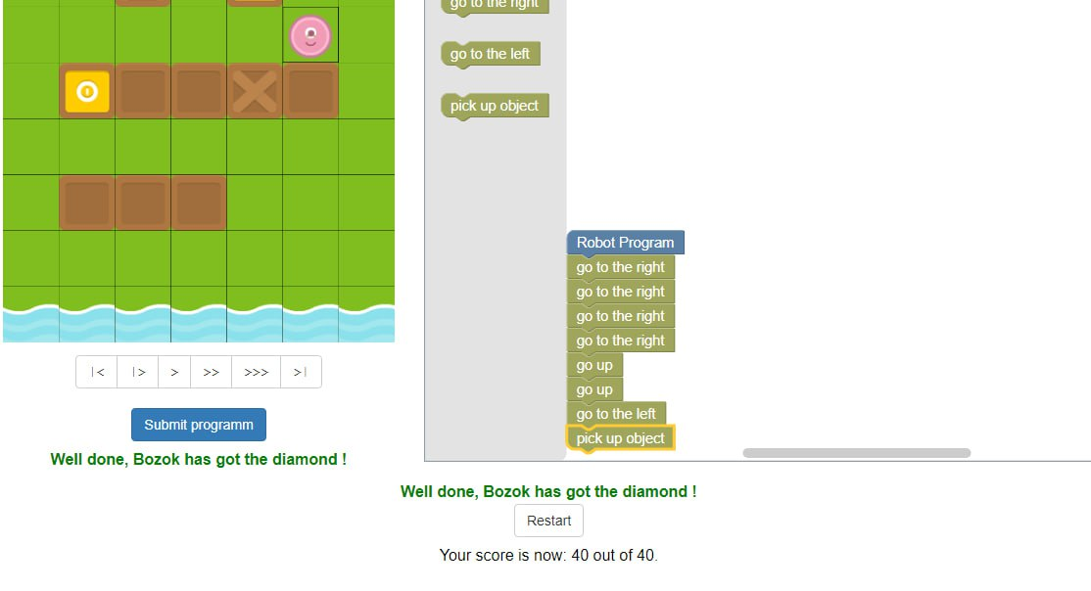

[4. Yellow and orange](https://pnc-blocky.netlify.app/exercices/2019/e-1-3/index.html)

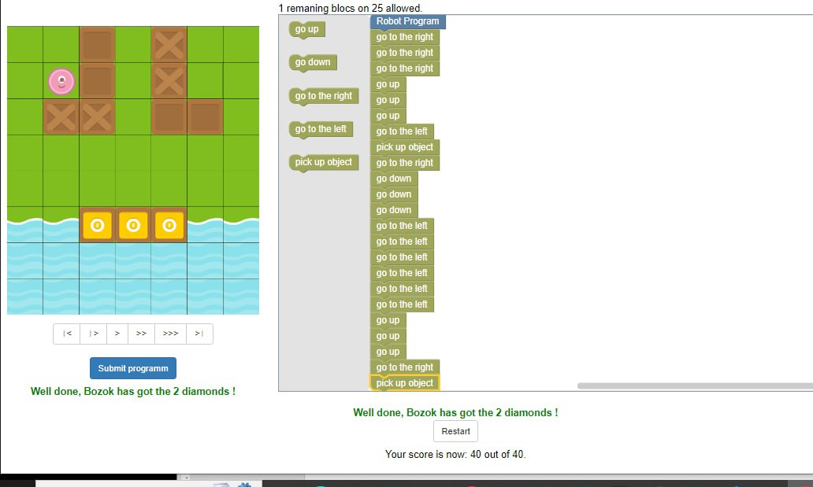

[5. Let s jump](https://pnc-blocky.netlify.app/exercices/2019/e-1-4/index.html)

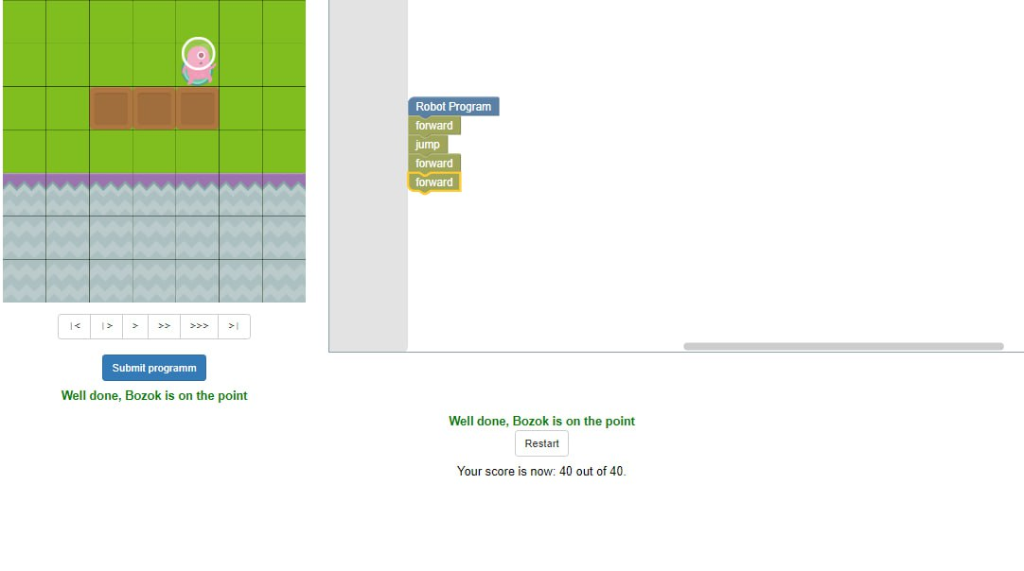

[6. The orange diamond](https://pnc-blocky.netlify.app/exercices/2019/e-1-5/index.html)

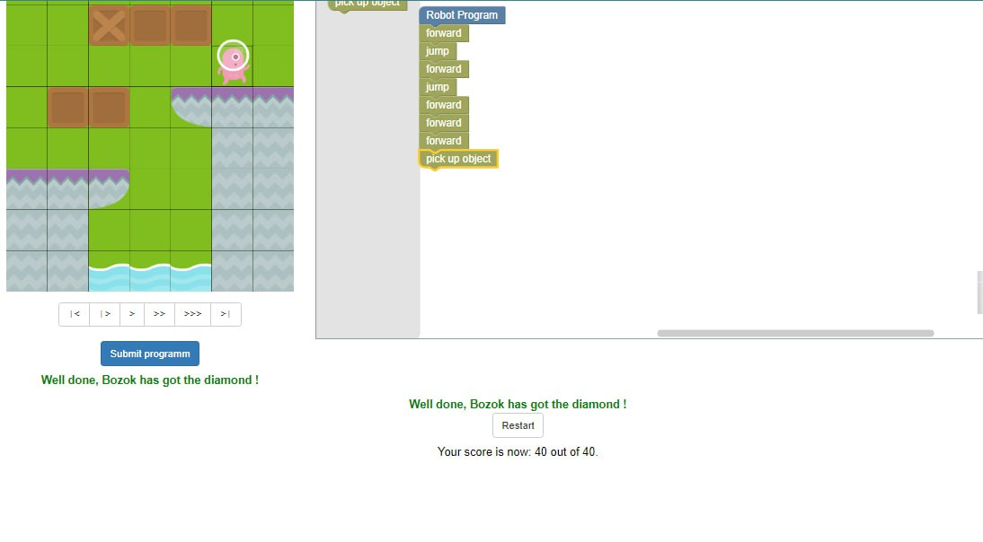

[7. The far away mushroom](https://pnc-blocky.netlify.app/exercices/2019/e-2-1/index.html)

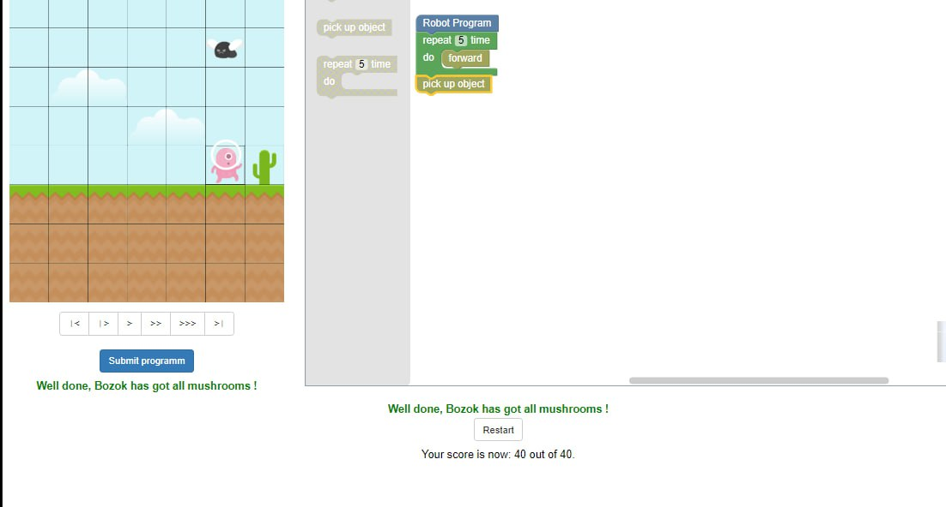

[8. Mushrooms everywhere](https://pnc-blocky.netlify.app/exercices/2019/e-2-2/index.html)

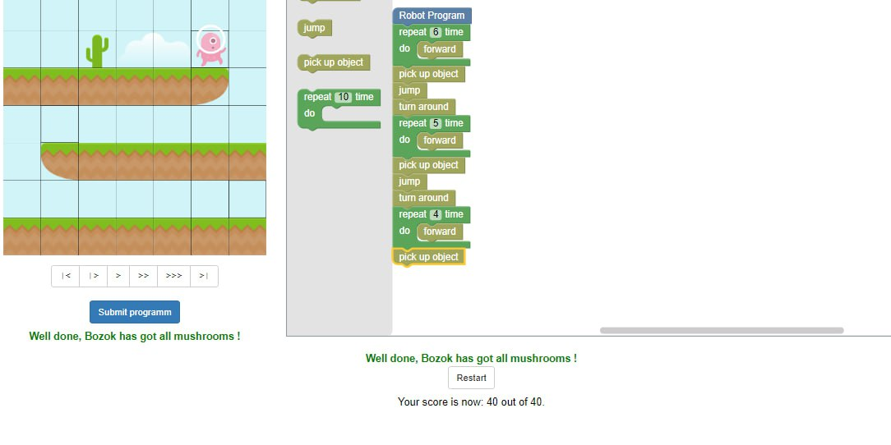

[9. Go to EXIT](https://pnc-blocky.netlify.app/exercices/2019/e-2-3/index.html)

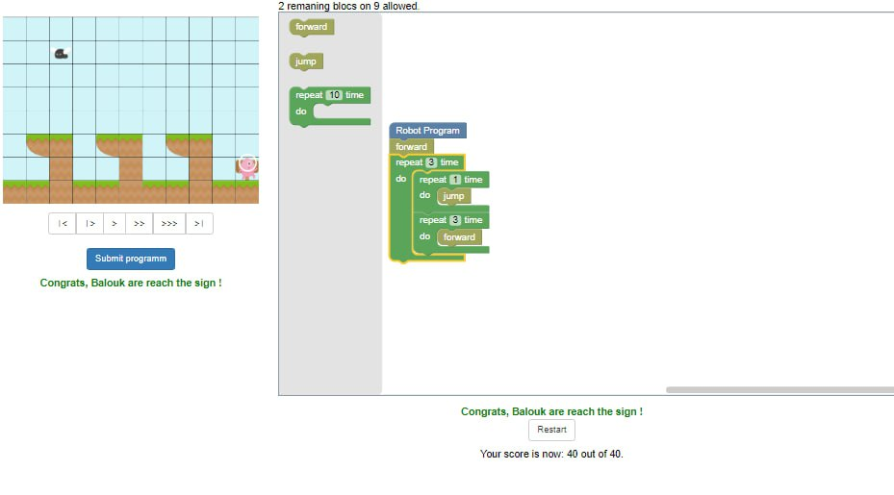

[10. Goomo and the key](https://pnc-blocky.netlify.app/exercices/2019/e-2-4/index.html)

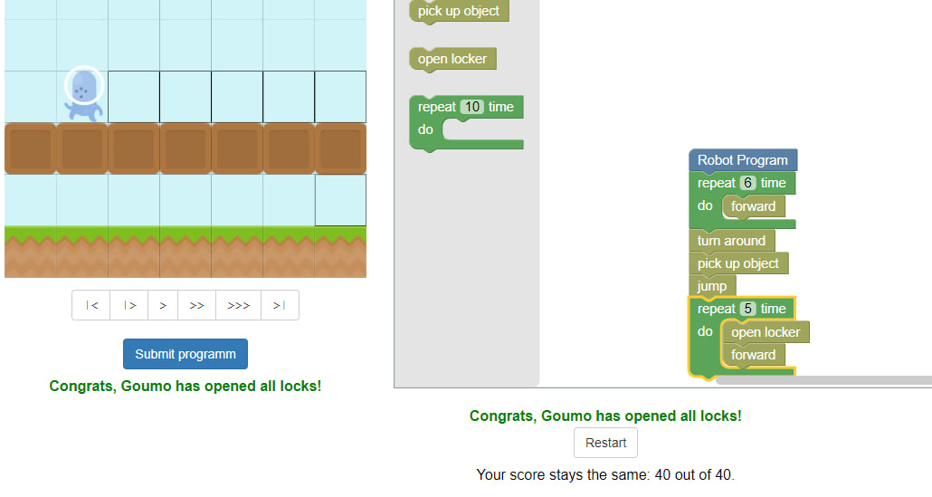

[11. Keys and locks](https://pnc-blocky.netlify.app/exercices/2019/e-3-1/index.html)

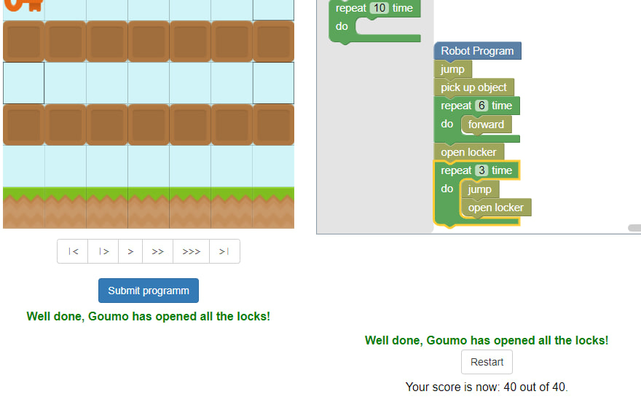

[12. The platfroms](https://pnc-blocky.netlify.app/exercices/2019/e-3-2/index.html)

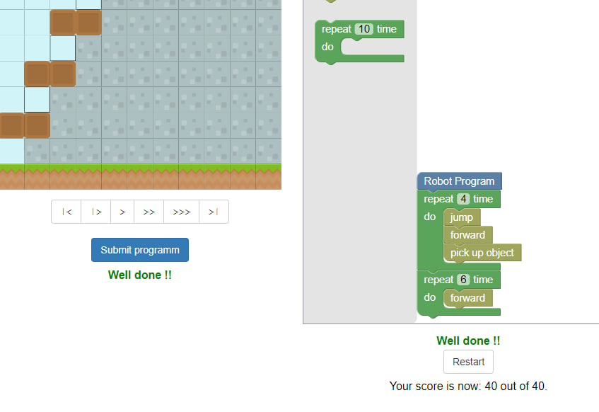

[13. The diamonds and the flag 1](https://pnc-blocky.netlify.app/exercices/2019/e-3-4/index.html)

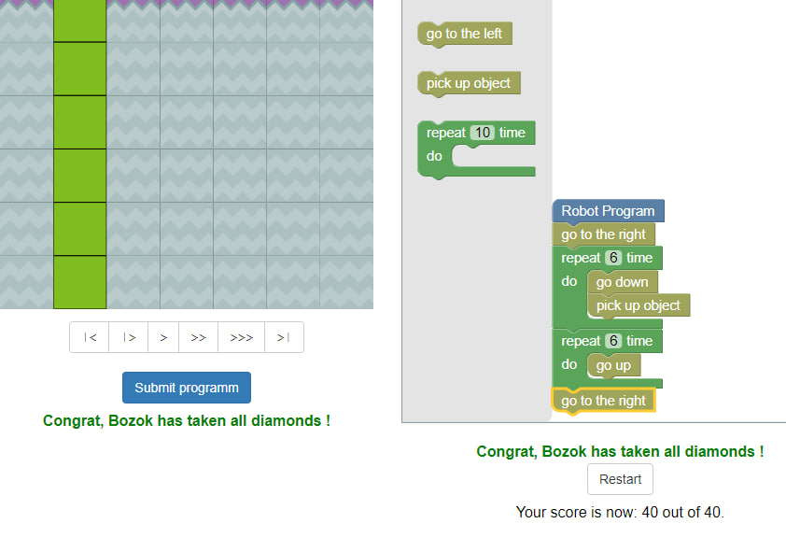

[14. The diamonds and the flag 2](https://pnc-blocky.netlify.app/exercices/2019/e-3-5/index.html)

[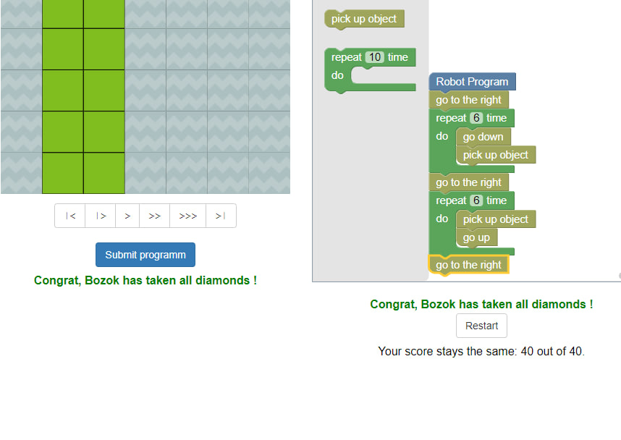](https://pnc-blocky.netlify.app/exercices/2019/e-3-5/index.html)

[15. The diamonds and the flag 3](https://pnc-blocky.netlify.app/exercices/2019/e-3-6/index.html)

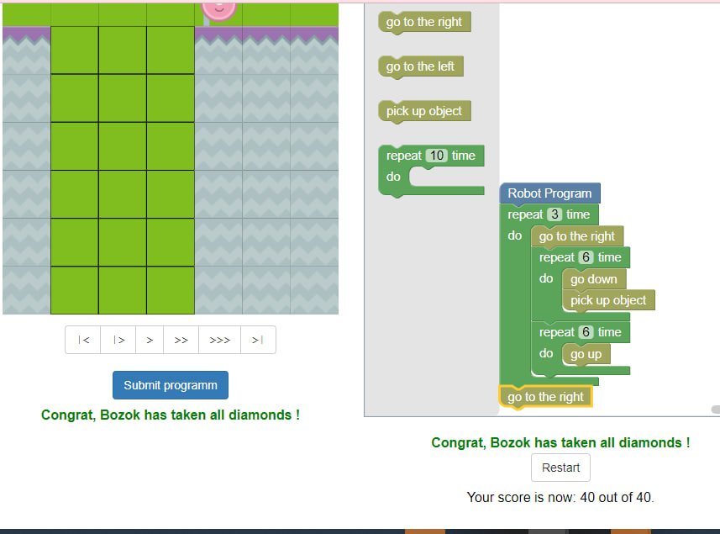

[16. The square of diamonds !](https://pnc-blocky.netlify.app/exercices/2019/e-3-3/index.html)

